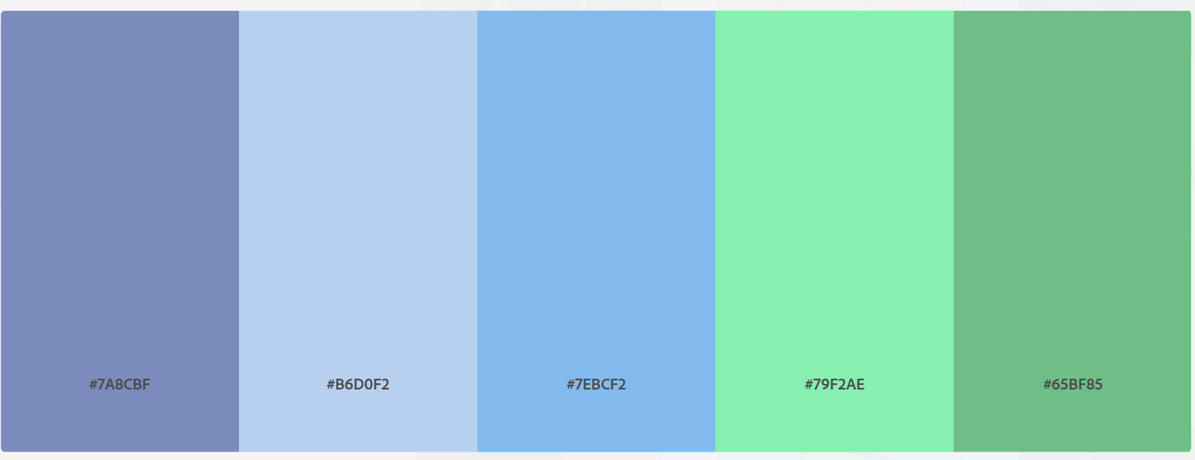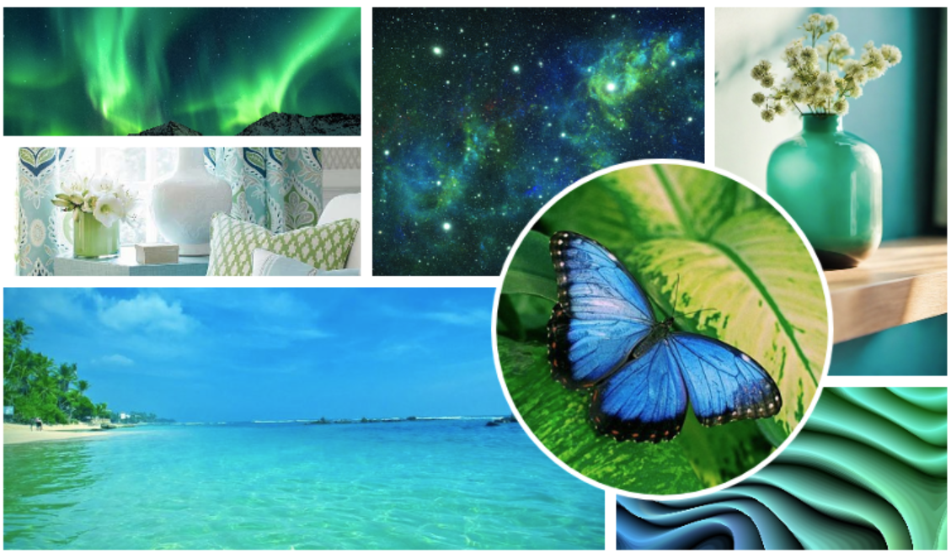

Inspiring keywords:

* Inviting
* Relaxing
* Comfortable
* Flow
* Aurora